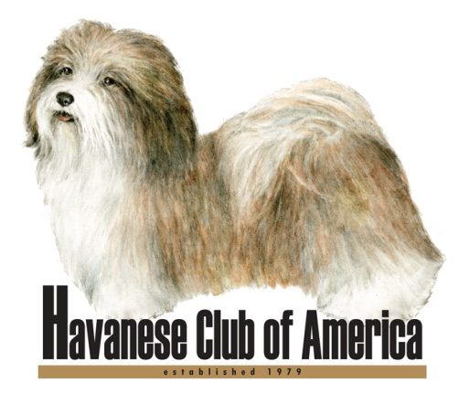

Julie Vogel, HCA MC Chair
E-Mail: giddyuphorse@msn.com • www.havanese.org

Thank you for your interest in joining the Havanese Club of America (HCA).

The HCA is an American Kennel Club (AKC) approved parent breed and member club. It exists to protect and advance the interests of the Havanese breed, in accordance with its Constitution, Bylaws, and Code of Ethics. HCA Membership is open to serious Havanese owners and fanciers who meet the minimum eligibility requirements and standards specified below.
  - Must own or co-own at least one AKC registered Havanese. A copy of the AKC registration for at least one Havanese owned or co-owned by each applicant is required.
  - Must be in good standing with the AKC. In addition, any complaints filed with the HCA Recording Secretary must be satisfactorily resolved.
  - Must have written endorsements from two HCA members in good standing, who meet the eligibility requirements for sponsorship.
  - Must have demonstrated a significant ongoing interest in the Havanese breed through active participation at the local and/or national level.
  - Must read and agree to abide by the HCA Constitution, Bylaws, and Code of Ethics which includes subscribing to HCA objects listed below:

    - To encourage and promote quality in the breeding of purebred Havanese and to do all possible to bring their natural qualities to perfection.
    - To encourage the organization of independent local Havanese Specialty Clubs in those localities where there are sufficient fanciers of the breed to meet the requirements of the AKC.
    - To urge members and breeders to accept the standard of the breed as approved by the AKC as the only standard of excellence by which Havanese shall be judged.
    - To do all in its power to protect and advance the interests of the breed and to encourage sportsmanlike competition at dog shows, obedience trials and tracking tests.
    - To conduct sanctioned matches, specialty shows, obedience trials, and tracking tests under the rules of the AKC.
    - To guard against the commercial exploitation of the Havanese breed.

The accompanying application is your opportunity to help the HCA Membership Committee (MC) and Board of Directors determine your eligibility for membership. Any and all information that you and your endorsers supply will help to determine whether you and the HCA share common goals. Feel free to attach extra pages with more information. Make sure you answer all questions. If any questions are not applicable to you (e.g. breeding questions for a pet owner) simply state N/A. Incomplete applications will be returned and will delay the vote for your acceptance into the HCA.

Please have the attached endorsement forms completed by two individuals who have been members of the HCA for at least two years and who continue to be members in good standing. In addition, both endorsers may not come from the same household membership. These endorsers should have personal knowledge of both you and your Havanese. Ideally at least one of the endorsers will have visited your home.

What types of things will the Membership Committee look for in new applicants?
- Past experience (includes competition, breeding, rescue, club involvement, etc.) with Havanese and/or other breeds.
- History of active involvement in local and/or national breed clubs. This includes holding office, participating on committees, supporting Club activities such as Specialties, Nationals, fund-raising activities, rescue etc.
- Previous experience in the HCA or local Havanese club at the volunteer level.
- A history of commitment to excellence in breeding to the Breed Standard.
- Proven ability to work well with others.
- Health testing of breeding stock for applicants who either currently breed or plan to breed. CERF testing should be performed annually. OFA Hips/LCP, OFA Elbows, OFA Patellas, OFA Cardiac, and BAER testing are also recommended for breeding stock. You may want to visit the CHIC, CERF and OFA websites to learn more about health testing. We consider health testing to be of paramount importance as it is a key action members can perform to protect and advance the breed.

The HCA encourages its members to become involved with club activities, whether on local or national level. Please seriously consider which of the areas interest you as volunteer opportunities. You can also support the HCA in other ways by participating in National and Local Specialty Shows and events.

You may find it helpful to become involved in a local Havanese club either prior to or in addition to applying for membership in the HCA. Our local clubs provide an excellent opportunity to network and receive support from other nearby Havanese owners. These clubs are of benefit to those who wish to show and breed their Havanese as well as to those whose interest in their Havanese is strictly as a companion. Many local clubs also have individuals involved with obedience, rally, agility, therapy, etc. To view a current listing of local Havanese clubs, please visit the HCA website at www.havanese.org.

Keep in mind that it typically takes between 3 to 6 months from the time the Membership Committee receives your completed application form and endorsement forms until you are informed whether or not your membership application has been approved.

If you have questions, please contact me.

Sincerely,

Julie Vogel
HCA Membership Committee Chair

