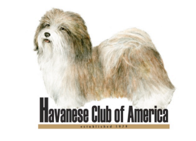

Dear Applicant,
Thank you for requesting membership information for the Havanese Club of America, AKC’s approved parent club for the Havanese.
Attached to this e-mail are three different files that make up a Havanese Club of America Membership Application Package. The first file, HCA Application Package, states what the requirements are for being a member in the Havanese Club of America. The second file, HCA Application Form, is the four page application to the Havanese Club of America for you to fill out. The third file, HCA Application Endorsement Form, is a form for you to give to two current members of the Havanese Club of America who have known you for two years and have indicated that they are willing to sponsor your membership.
Your application, a check for the correct amount payable to HCA, and the two endorsement forms must be received before the membership process begins. Your name will be printed in the Havanese Newsletter, one of the club’s official publications, for HCA member comments. After the deadline for member comments, the Membership Committee will meet and discuss the applications, and make their recommendation to the Board of Directors. The Board will meet and vote on applications for membership. This process can take six to nine months.
If you have any questions, please feel free to contact me at giddyuphorse@msn.com.
Julie Vogel
Membership Chair
Havanese Club of America

